NOTICE OF PUBLIC MEETING
CONCERNING A PROPOSED AMENDMENT TO THE HOWICK ZONING BY-LAW,
AFFECTING THE TOWNSHIP OF HOWICK

TAKE NOTICE that Council of the Township of Howick will hold a public meeting on Tuesday November 26, 2024 at 9:00am in the Council Chambers of the Township of Howick municipal office, 44816 Harriston Rd, Gorrie to consider a proposed Zoning By-law Amendment under Section 34 of the Planning Act, R.S.O. 1990, as amended. You are entitled to attend this public meeting by attending in person or joining via teleconference by calling 519-335-6338 & using the participant code 5210023, to express your views about this application. If you plan to join by teleconference, please register with Clerk-Administrator Caitlin Gillis know by noon on November 25, 2024.

BE ADVISED that the Township of Howick considered this application to be complete on November 4, 2024.

ANY PERSON may attend the public meeting and/or make written or verbal representation either in support or in opposition to the proposed zoning by-law amendment.

Members of the public do not have the right to appeal the decision; only the applicant, the property owner, the Minister of Municipal Affairs and Housing, a specified person under the Planning Act or public body that has an interest in the matter, may appeal the decision. Please refer to the County of Huron website for details about appeal rights: https://www.huroncounty.ca/plandev/guides-and-resources/planningprocedures/additional-appeal-information

IF you wish to be notified of the decision of the Township of Howick on the zoning by-law amendment, you must make a written request to the Township of Howick at the address listed below.

ADDITIONAL INFORMATION relating to the proposed by-law amendment is available for inspection during regular office hours at the Township of Howick Office, 44816 Harriston Rd, Gorrie.

COUNCIL MEETINGS are being held in person, with a call-in option. Persons wishing to participate in the planning process are strongly encouraged to send their comments, questions or concerns via email to Planner Jenn Burns at planning@huroncounty.ca (519-524-8394 ext. 3). Please provide comments by November 18th, 2024 to allow them to be incorporated into the staff report and agenda.

Dated at the Township of Howick this 4th day of November, 2024

Caitlin Gillis, Clerk-Administrator
Township of Howick,
44816 Harriston Rd, Gorrie N0G 1X0
(519)-335-3208

PURPOSE AND EFFECT
This zoning by-law amendment affects property legally described as HOWICK CON 9 PT LOT 5 RP;22R7229 PART 3. The rezoning is a condition of Huron County’s approval of Consent Applications C48-2024, C49-2024 and C50-2024. This application seeks to rezone approximately 5.5 acres from D (Development) to VR1 (Village Residential- Low Density) to allow for future low-density residential development. The property is designated D-Urban in the Howick Official Plan.

THE CORPORATION OF THE TOWNSHIP OF HOWICK
DRAFT BY-LAW - 2024

WHEREAS the Municipal Council of the Corporation of the Township of Howick considers it advisable to amend Howick Zoning By-law 23-1984, as amended, of the Corporation of the Township of Howick; and

NOW THEREFORE the Council of the Corporation of the Township of Howick ENACTS as follows:

- This by-law shall apply to HOWICK CON 9 PT LOT 5 RP;22R7229 PART 3 in the Township of Howick, and is comprised of Schedules 1-4.

- By-law 23-1984 is hereby amended on Zoning Key Map “Gorrie” by changing the zone symbol from D-Urban to VR1 for property identified on the attached Schedules 2 and 3.

- All other provisions of By-law 23-1984 shall apply.

- This by-law shall come into force pursuant to Section 34(21) of the Planning Act, RSO 1990, as amended.

READ A FIRST TIME ON THE 26th DAY OF NOVEMBER , 2024.
READ A SECOND TIME ON THE 26th DAY OF NOVEMBER , 2024.
READ A THIRD TIME AND PASSED THIS 26th DAY OF NOVEMBER , 2024.

_______________________________
Doug Harding, Reeve Caitlin Gillis, Clerk-Administrator
SCHEDULE 1
CORPORATION OF THE TOWNSHIP OF HOWICK
BY-LAW - 2024

By-law - 2024 has the following purpose and effect:

- This zoning by-law amendment affects property legally described as HOWICK CON 9 PT LOT 5 RP;22R7229 PART 3. The rezoning is a condition of Huron County’s approval of Consent Applications C48-2024, C49-2024 and C50-2024. This application seeks to rezone approximately 5.5 acres from D (Development) to VR1 (Village Residential- Low Density) to allow for future low-density residential development. The property is designated D-Urban in the Howick Official Plan.

- This by-law amends the Township of Howick Zoning By-law 23-1984. All other zone provisions apply.

- The location map and detail map showing the location to which this by-law applies are found on the following pages and are entitled Schedule 2 & Schedule 3.

SCHEDULE 2
THE CORPORATION OF THE TOWNSHIP OF HOWICK
DRAFT BY-LAW - 2024
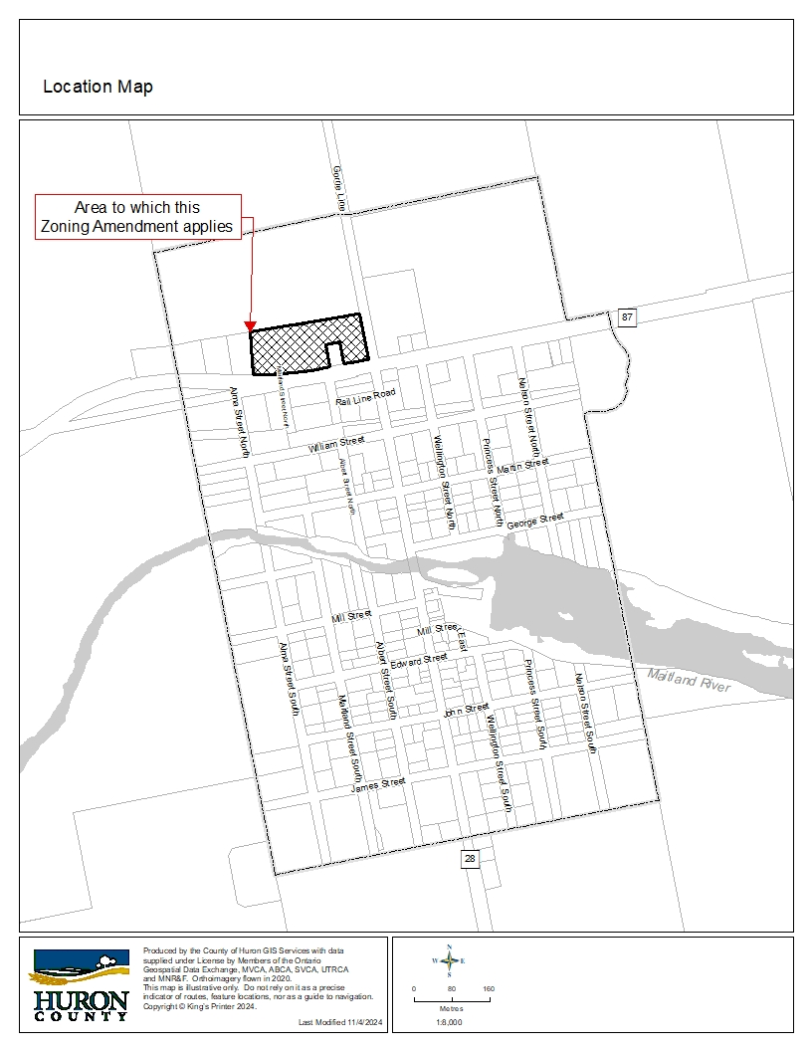

SCHEDULE 3
THE CORPORATION OF THE TOWNSHIP OF HOWICK
DRAFT BY-LAW - 2024
